Index

|  |  |  |
| --- | --- | --- |
| **Sr. No.** | **Contents** | **Page No.** |
| **1** | **Annexure I– Micro Project Proposal** | **1-2** |
| 1.Aims/Benefits of the Micro-Project | 1 |
| 2. Course Outcome Addressed | 1 |
| 3.Proposed Methodology | 1 |
| 4. Action Plan | 2 |
| 5. Resources Required | 3 |
| 6. Name of Team Members with Roll No.’s | 4 |
| **2** | **Annexure II – Micro Project Report** | **5-8** |
| 1.Rationale | 5 |
| 2.Aims/Benefits of the Micro-Project | 5 |
| 3.Course Outcome Achieved | 5 |
| 4. Literature Review | 5 |
| 5.Actual Methodology Followed | 5 |
| 5.1 Syntax | 6 |
| 5.2 Source code | 6-9 |
| 6.Actual Resources Used | 9 |
| 7.Outputs of Micro-Projects | 10 |
| 8. Skill developed / Learning out of this Micro-Project | 11 |
| 9. Applications of this Micro-Project | 11 |

## Annexure I

**Micro Project Proposal**

# *develop a Code editor applicaton using vb.net framework*

## Aims/Benefits of the Micro-Project:

* + Creating a useful and functional media player application that you can use yourself or share with others.
  + Improving your knowledge of Panel, Tab Index and Dock techniques.
  + Enhancing your programming skills in VB.NET and gaining experience in developing a desktop application.

## Course Outcome Addressed:

* CO1 - Use Visual Studio IDE to design application.
* CO2 - Develop GUI Application using Form Controls and its events.
* CO3 - Apply Object Oriented concepts in GUI Application.
* CO4 - Use Data access controls to store data in Database and retrieve it.
* CO5 - Use Data Binding in GUI Application.

## Proposed Methodology:

We are able to make a code editor application we edits the HTML code and show its output in the web browser. It becomes very easy to write the code with the code editor Soft code editor is used to convert the html code in such way that its shows the output on the website without copy pasting the address bar and opening the live server.

It is very relevant to write the code and do operations on the code.

1. **Action Plan:**

|  |  |  |  |  |
| --- | --- | --- | --- | --- |
| **Sr.**  **No.** | **Details of Activity** | **Planned**  **Start date** | **Planned**  **Finish date** | **Name of Responsible**  **Team Members** |
| 1 | Search the topic | 10/02/2023 3:30pm-4:30pm | 11/02/2023 3:30pm-4:30pm | Akshay Dashrath Gitte |
| 2 | Search the information | 17/02/2023 3:30pm-4:30pm | 3/03/2023 3:30pm-4:30pm |
| 3 | Algorithm developing | 4/03/2023 3:30pm-4:30pm | 10/03/2023 3:30pm-4:30pm |
| 4 | Flowchart developing  *(This project not consists!) | 11/3/2023 3:30pm-4:30pm | 17/03/2023 3:30pm-4:30pm | Harsh Moreshwar  Kale  Kunal Nitin Nalwade |
| 5 | Function making | 18/3/2023 3:30pm-4:30pm | 25/03/2023 3:30pm-4:30pm |
| 6 | Coding developing | 31/3/2023 3:30pm-4:30pm | 01/4/2023 3:30pm-4:30pm |
| 7 | Debugging | 07/4/2023 3:30pm-4:30pm | 08/4/2023 3:30pm-4:30pm |
| 8 | Finalizing Project with its report | 15/4/2023 3:30pm-4:30pm | 21/4/2023 3:30pm-4:30pm |

1. **Resources Required:**

|  |  |  |  |  |
| --- | --- | --- | --- | --- |
| **Sr. No**  **.** | **Name of resource / material** | **Specification** | **Quantity** | **Remarks** |
| 1 | Computer | WINDOWS 11,8GB RAM | 1 |  |
| 2 | Operating System | WINDOWS 11 | 1 |  |
| 3 | Software | Visual Studio 2021 | 1 |  |
| 4 | Browser | Google Chrome | 1 |  |

## Names of Team Members with Roll No.’s:

|  |  |  |  |
| --- | --- | --- | --- |
| **Sr.**  **No.** | **Enrollment No.** | **Name of Team Member** | **Roll No.** |
| 1 | 2110950049 | Akshay Dashrath Gitte | 01 |
| 2 | 2110950051 | Harsh Moreshwar Kale | 03 |
| 3 | 2210950151 | Kunal Nitin Nalwade | 60 |

**Mr. Chavan A. Y.**

## Name and Signature of the Teacher

**Annexure – II**

**Micro-Project Report**

# *develop a Code editor applicaton using vb.net framework*

## Rationale:

Enhance Programming Skills: Developing a media player application requires a good understanding of programming concepts such as file handling, user interface design, event handling, and multimedia programming. Practical Application: Media player applications are widely used on various platforms such as desktop, mobile, and web.

Flexibility: The VB.NET framework provides a lot of flexibility for developing multimedia applications.

1. **Aims/Benefits of the Micro-Project:**
   * Enhancing your programming skills in VB.NET and gaining experience in developing a desktop application.
   * Improving your knowledge of Panel, Tab Index and Dock techniques.
   * Creating a useful and functional media player application that you can use yourself or share with others.

## Course Outcomes Achieved:

1. CO1 - Use Visual Studio IDE to design application.

2. CO2 - Develop GUI Application using Form Controls and its events.

3. CO3 - Apply Object Oriented concepts in GUI Application.

4. CO4 - Use Data access controls to store data in Database and retrieve it.

5. CO5 - Use Data Binding in GUI Application.

## Literature Review:

Visual Studio is a very user friendly tool. But there is enough stuff to confuse any one new to Visual Studio family. The purpose of this is to make me familiar with different options in Visual Studio.NET (VS.NET). You will not cover the entire visual studio guide. You just explaining the most commonly used features of VS.NET.

We are able to make a code editor application we edits the HTML code and show its output in the web browser.

## 1. Actual Methodology followed

* Identify the project requirements and define the scope and objectives of the project.
* Plan the project by breaking it down into smaller tasks and setting realistic timelines and milestones.
* Design the user interface by creating a wireframe or prototype of the application layout and controls.
* Determine the architecture of the application by deciding on the data model and how the application will handle HTML files, converting it into docttype, and user interactions.
* Implement the design by writing the code in VB.NET and using the built-in classes and methods to create the Code editor application.
* Test the application to identify and fix any issues and ensure it functions correctly.
* Document the project by creating user manuals, technical specifications, and other relevant documentation.
* Deploy the application by making it available for users to download and use.
* Maintain the application by fixing bugs, adding new features, and keeping it up to date with changes in html file formats and converting techniques.
* It's important to keep in mind that the methodology you follow may vary depending on the project requirements and your development approach. It's recommended to follow a structured and organized approach to ensure the project is completed on time and meets the required quality standards.

**5.2. Source code**

'Soft Code Editor Application

'Team Members

'Manager = Akshay Dashrath Gitte

'Developer = Harsh Moreshwar Kale

'Tester = Kunal Nitin Nalwade

Public Class Form1

Private Sub load_editor()

Dim Editor As New Editor

With Editor

.Dock = DockStyle.Fill

End With

Dim t As New TabPage

With t

.Text = "New Document"

.Name = "New Editor"

End With

t.Controls.Add(Editor)

Me.TabControl1.Controls.Add(t)

End Sub

Private Sub Form1_Load(sender As Object, e As EventArgs) Handles Me.Load

load_editor()

End Sub

Private Sub PictureBox3_Click(sender As Object, e As EventArgs) Handles PictureBox3.Click

Application.Exit()

End Sub

Private Sub PictureBox2_Click(sender As Object, e As EventArgs) Handles PictureBox2.Click

If Me.WindowState = FormWindowState.Normal Then

Me.WindowState = FormWindowState.Maximized

Else

Me.WindowState = FormWindowState.Normal

End If

End Sub

Private Sub PictureBox1_Click(sender As Object, e As EventArgs) Handles PictureBox1.Click

Me.WindowState = FormWindowState.Minimized

End Sub

Private Sub PictureBox6_Click(sender As Object, e As EventArgs) Handles PictureBox6.Click

load_editor()

End Sub

Private Sub PictureBox5_Click(sender As Object, e As EventArgs) Handles PictureBox5.Click

TabControl1.TabPages.Remove(TabControl1.SelectedTab)

End Sub

End Class

'Soft Code Editor Application

'Team Members

'Manager = Akshay Dashrath Gitte

'Developer = Harsh Moreshwar Kale

'Tester = Kunal Nitin Nalwade

Public Class Editor

Private Sub FastColoredTextBox1_Load(sender As Object, e As EventArgs)

End Sub

Private Sub FastColoredTextBox1_Load_1(sender As Object, e As EventArgs)

End Sub

Private Sub PictureBox12_Click(sender As Object, e As EventArgs)

'WebBrowser1.DocumentText = FastColoredTextBox1.Text

If FastColoredTextBox1.Visible = True Then

FastColoredTextBox1.Visible = False

WebBrowser1.DocumentText = FastColoredTextBox1.Text

WebBrowser1.Visible = True

Else

FastColoredTextBox1.Visible = True

WebBrowser1.Visible = False

End If

End Sub

Private Sub PictureBox10_Click(sender As Object, e As EventArgs)

FastColoredTextBox1.Copy()

End Sub

Private Sub PictureBox11_Click(sender As Object, e As EventArgs)

FastColoredTextBox1.Paste()

End Sub

Private Sub PictureBox8_Click(sender As Object, e As EventArgs)

FastColoredTextBox1.Undo()

End Sub

Private Sub PictureBox9_Click(sender As Object, e As EventArgs)

FastColoredTextBox1.Redo()

End Sub

Private Sub PictureBox1_Click(sender As Object, e As EventArgs)

FastColoredTextBox1.Clear()

End Sub

Private Sub WebBrowser1_DocumentCompleted(sender As Object, e As WebBrowserDocumentCompletedEventArgs) Handles WebBrowser1.DocumentCompleted

End Sub

Private Sub FastColoredTextBox1_Load_2(sender As Object, e As EventArgs) Handles FastColoredTextBox1.Load

End Sub

Private Sub PictureBox11_Click_1(sender As Object, e As EventArgs) Handles PictureBox11.Click

FastColoredTextBox1.Paste()

End Sub

Private Sub PictureBox10_Click_1(sender As Object, e As EventArgs) Handles PictureBox10.Click

FastColoredTextBox1.Copy()

End Sub

Private Sub PictureBox9_Click_1(sender As Object, e As EventArgs) Handles PictureBox9.Click

FastColoredTextBox1.Undo()

End Sub

Private Sub PictureBox8_Click_1(sender As Object, e As EventArgs) Handles PictureBox8.Click

FastColoredTextBox1.Redo()

End Sub

Private Sub PictureBox1_Click_1(sender As Object, e As EventArgs) Handles PictureBox1.Click

FastColoredTextBox1.Clear()

End Sub

Private Sub PictureBox12_Click_1(sender As Object, e As EventArgs) Handles PictureBox12.Click

If FastColoredTextBox1.Visible = True Then

FastColoredTextBox1.Visible = False

WebBrowser1.DocumentText = FastColoredTextBox1.Text

WebBrowser1.Visible = True

Else

FastColoredTextBox1.Visible = True

WebBrowser1.Visible = False

End If

End Sub

End Class

## 6. Actual Resources Used:

|  |  |  |  |  |
| --- | --- | --- | --- | --- |
| **Sr.**  **No.** | **Name of resource / material** | **Specification** | **Quantity** | **Remarks** |
| 1 | Computer | WINDOWS 11,8 GB  RAM | 1 |  |
| 2 | Operating System | WINDOWS 11 | 1 |  |
| 3 | Software | Visual Studio 2021 | 1 |  |
| 4 | Browser | Google Chrome | 1 |  |

1. **Outputs of Micro-Projects:**

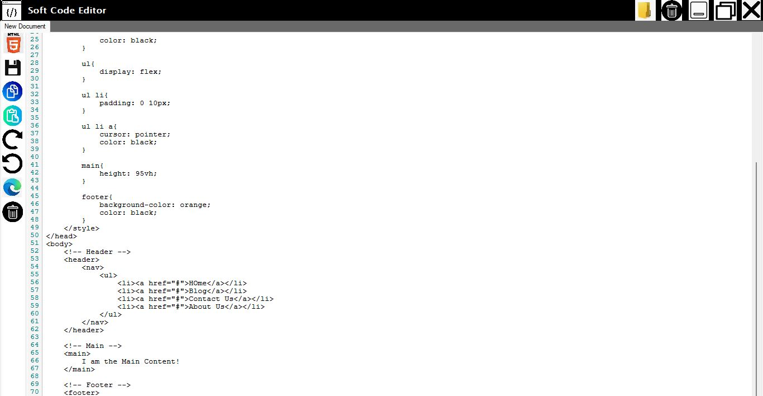

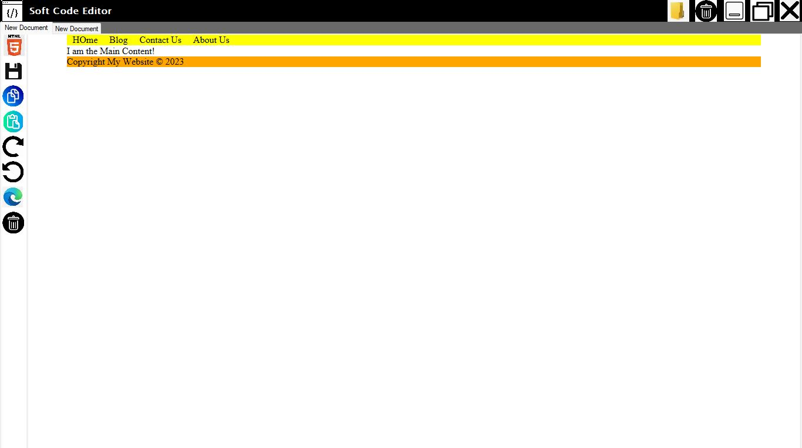

## Skill developed / Learning out of this Micro-Project:

## There are so many thing that we learn from this project of

## 1. VB.NET programming skills.

## 2. User interface design

## 3 .WEB file formats and Docking, Anchoring techniques

## 4. Object-oriented programming principle.

## 5. Debugging and problem-solving skills

## 6. Project management skills

## 7. Documentation skills

## 8. Confidence and motivation

## 9. Applications of this Micro-Project:

By using a trigger you can keep track of the changes on a given table by writing a log record with information about the user that made the change and what was changed.

####